Ethical Hacking Task 02: Network Scanning & Service Enumeration

Part A: Install Nmap
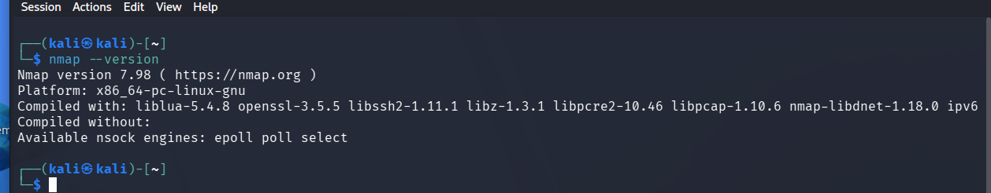
Part B: Scan Your Local Machine
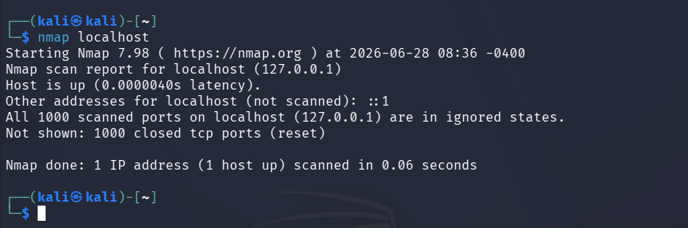
Document:
- Total Open Ports: 0
- Port Numbers: None
- Services Running: None

Part C: Service Version Detection
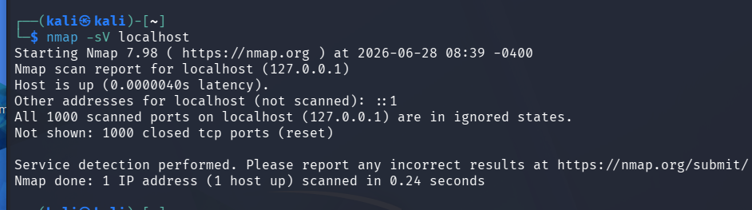

Port | Service | Version
None | None | None

The nmap -sV localhost scan did not detect any open ports. Since no services were running on the localhost, no service names or version information could be identified

Part D: Operating System Detection
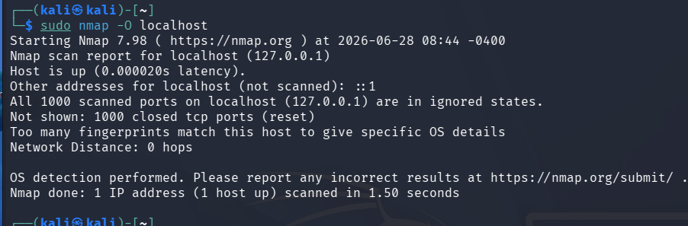
- Was the operating system detected?
No

- Which OS was identified?
Not detected
OS was not detecteddue to ”Too many fingerprints match this host to give specific OS details”

- Why is OS detection useful during penetration testing?
Operating system detection helps identify the target's operating system so that security professionals can choose appropriate security tests and assess vulnerabilities specific to that OS. It improves the accuracy and efficiency of a penetration test while reducing unnecessary or incompatible testing.

Part E: Common Port Research

Common Network Ports and Their Security Risks
Port | Protocol | Purpose | Common Security Risks
20/21 | FTP (File Transfer Protocol) | Transfers files between computers. | Credentials sent in plain text, unauthorized file access, brute-force attacks.
22 | SSH (Secure Shell) | Secure remote login and system administration. | Brute-force attacks, stolen SSH keys, weak passwords.
23 | Telnet | Remote access to devices. | Unencrypted communication, password theft, man-in-the-middle attacks.
25 | SMTP (Simple Mail Transfer Protocol) | Sends email between mail servers. | Spam relay abuse, email spoofing, phishing.
53 | DNS (Domain Name System) | Translates domain names into IP addresses. | DNS spoofing, cache poisoning, DNS amplification attacks.
80 | HTTP (Hypertext Transfer Protocol) | Delivers web pages over the internet. | Data transmitted without encryption, XSS, SQL injection, session hijacking.
110 | POP3 (Post Office Protocol v3) | Retrieves emails from a mail server. | Credentials transmitted in plain text (without encryption), unauthorized access.
143 | IMAP (Internet Message Access Protocol) | Accesses and manages emails stored on a mail server. | Weak authentication, data interception if encryption is not used.
443 | HTTPS (Hypertext Transfer Protocol Secure) | Securely delivers web pages using SSL/TLS encryption. | SSL/TLS misconfiguration, expired certificates, weak encryption.
445 | SMB (Server Message Block) | File and printer sharing on Windows networks. | Malware (e.g., WannaCry), unauthorized file access, remote code execution.
3389 | RDP (Remote Desktop Protocol) | Remote access to Windows computers. | Brute-force attacks, credential theft, remote exploitation if exposed to the internet.

- Which services are currently running?
No network services were running on my system. The Nmap scan found no open ports, so no active services were detected.

- Are all open ports necessary?
There were no open ports on my system. In general, only the ports required for a system's normal operation should be kept open. Unnecessary open ports should be closed to improve security.

- Which services could become security risks if misconfigured?
Services such as FTP, Telnet, SMB, RDP, SSH, and HTTP can become security risks if they use weak passwords, outdated software, or incorrect security settings. These issues may allow unauthorized access or other attacks.

- Which port would you disable if it wasn't required?
Since no ports were open, there was nothing to disable. In general, if Telnet (port 23) is not required, it should be disabled because it sends data, including passwords, without encryption. SSH (port 22) is a more secure alternative.

